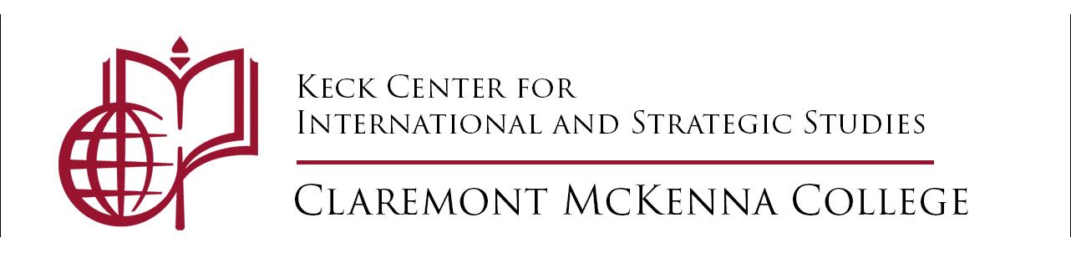

THE KECK CENTER WORLD AFFAIRS PODCAST PROGRAM
Applications due Monday, December 5 to keckcenter@cmc.edu & tjones@cmc.edu

We are excited to invite pairs of students to conduct research on a region or a theme in world affairs and develop three podcast episodes. Students selected for this fellowship will receive $1,000 disbursed in two payments. Under the supervision of Prof. Terril Jones, student teams will develop and post podcast episodes once a month (we instruct how to post to Spotify, but you may post to Apple Podcasts or another public platform). No previous experience in podcasting is required. The Keck Center will also post the podcasts on its website (https://www.cmckeckcenter.org/world-affairs-podcast-program). Students must commit to attend group training sessions with Prof. Jones on podcast development on five Friday mornings (time TBA, at 10 a.m.). First-year students are encouraged to apply. Preference will go to students who have not received support from the Keck Center in 2022. The final podcast is due Monday, May 1. Please consider if your schedule allows you to attend the training sessions and to meet the deadlines, and that your topic is specific and feasible. The first payment will be after teams post the first episode; the second after teams complete all three podcasts. You may direct any questions to Terril Jones at tjones@cmc.edu.
Name 1: _______________________________________________________________________________________
Last First Major Year

Name 2: _______________________________________________________________________________________
Last First Major Year
(You must apply in pairs. Please submit one application form per team with proposal and both resumes.)

Email: 1. ____________________________________ 2. __________________________________________

CMC Faculty References (not for first-year students): ____________________________________________

Student 1 Reference. _____________________________________________________

Student 2 Reference. _____________________________________________________

Are you available without conflicts to attend five Friday mornings at 10 a.m. for podcast meetings and training?

Proposed Topic of Podcast Series (in one sentence, or a possible title):

Please answer for both students: Any past podcasting experience? Any previous work at the Keck Center or earlier?

______________________________________________________________________________________________________

I have applied to the podcasting program before but was not chosen: Student 1) _____ Y/N Student 2) _____ Y/N

In addition to this form, please paste below a brief proposal (250 words) followed by your resume(s). Submit form and other materials in ONE FILE please. Students may submit same proposals as in previous competitions (if unfunded). This call is for students not previously selected for the Keck podcast program.

INCLUDE BRIEF (< 250 words) PROPOSAL HERE FOLLOWED BY RESUMES:

