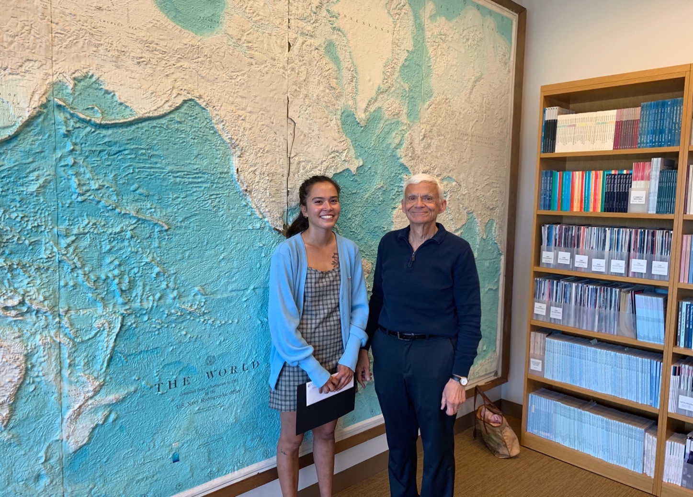
Charlotte Reinnoldt – Best Thesis in Comparative Political Economy (Advisor: Prof. Ascher)

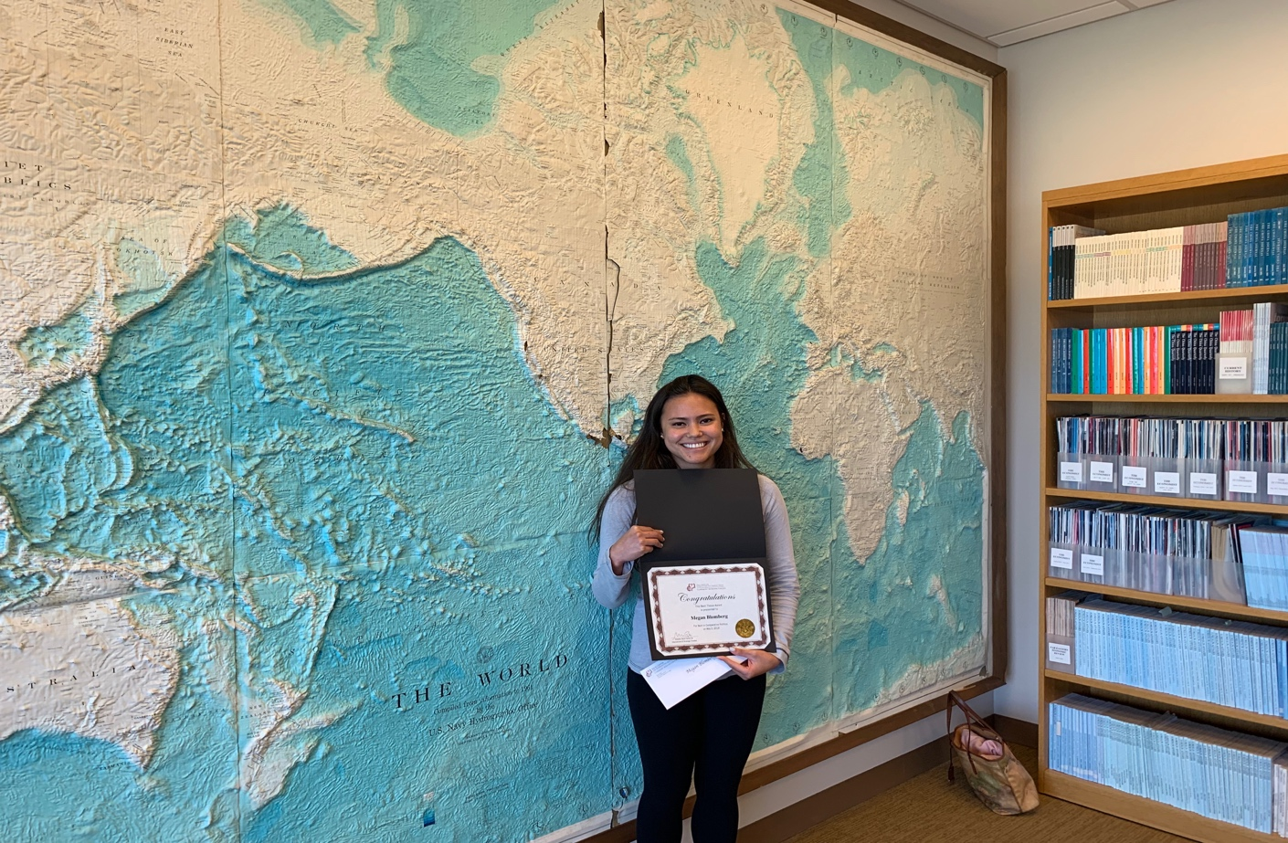
Megan Blomberg – Best Thesis in Comparative Politics (Advisor: Prof. Sinha)
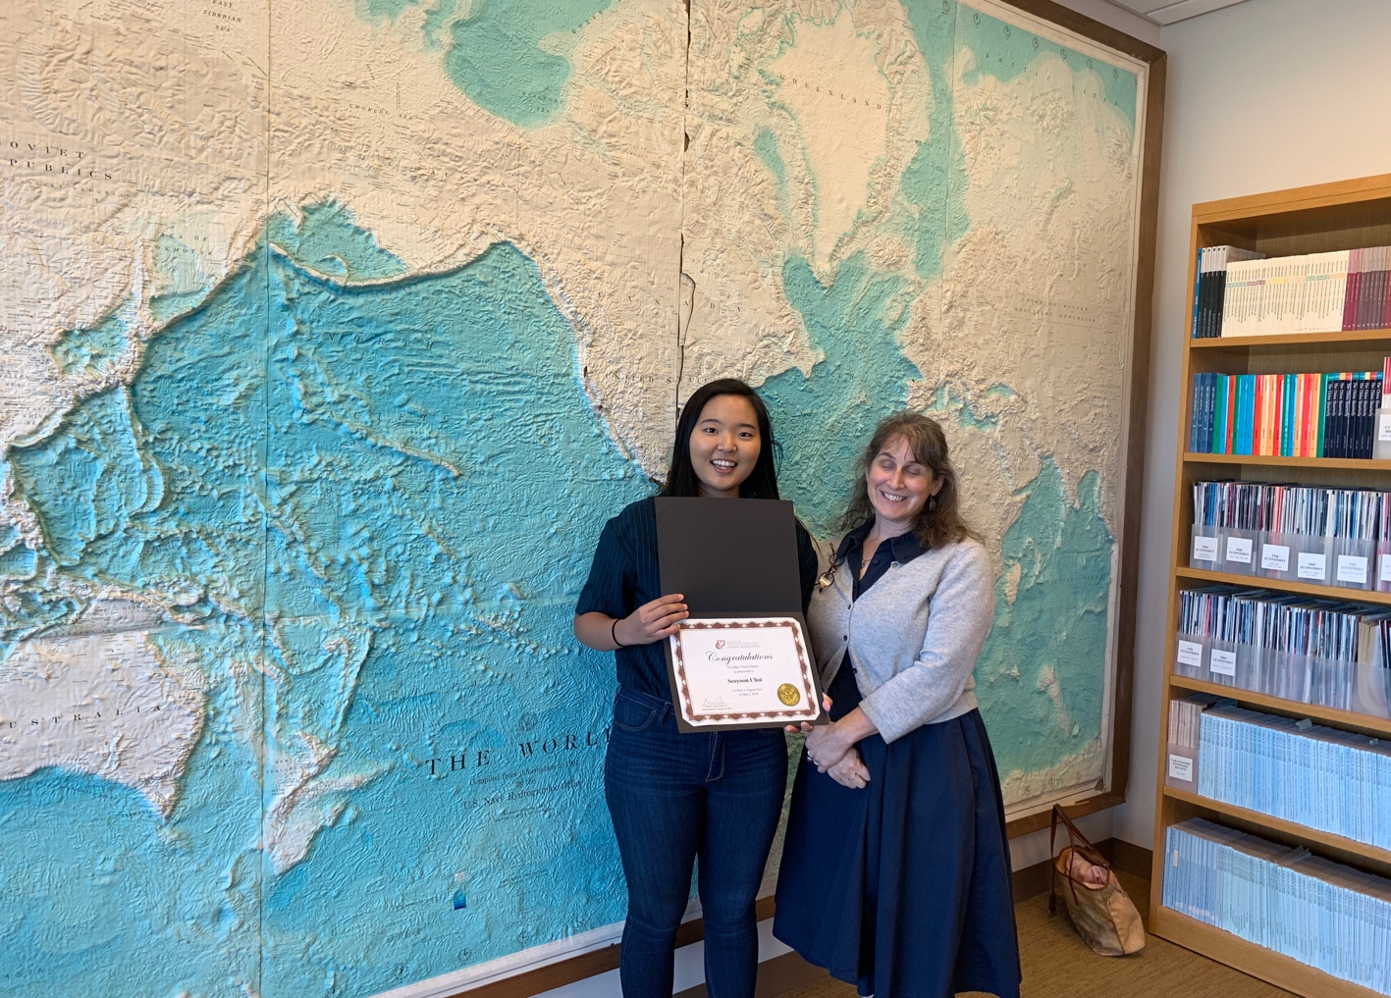
Seoyoon Choi – Best Original Idea (Advisor: Prof. Taw)

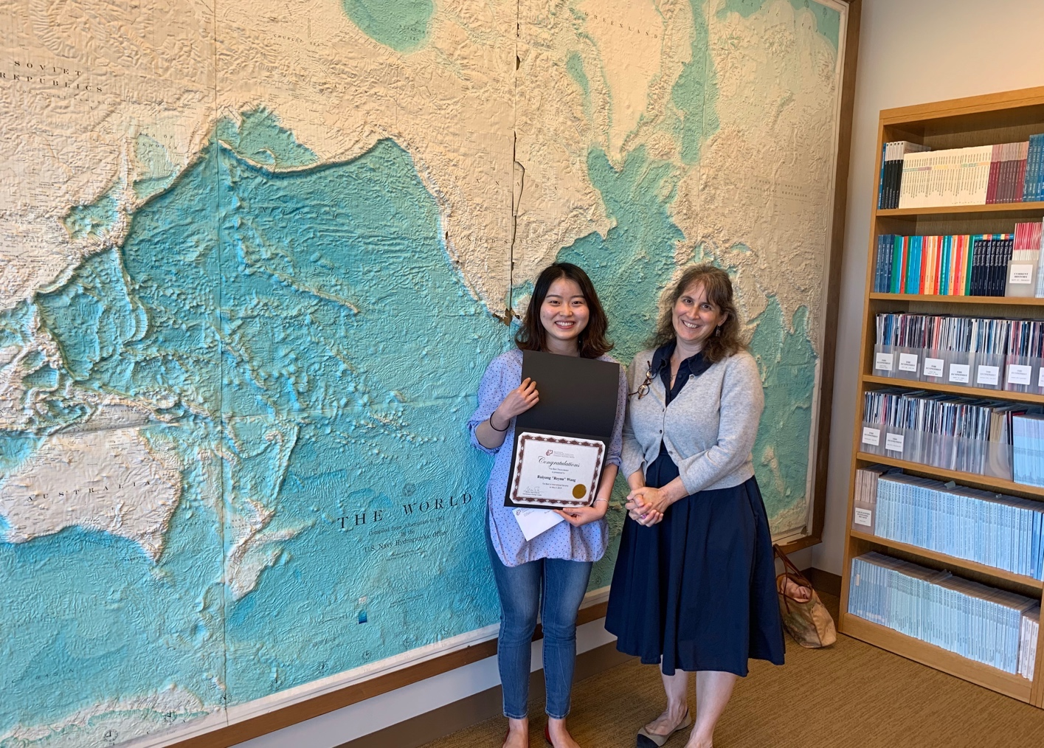
Ruiyang “Reyna” Wang – Best in International Security (Advisor: Prof. Taw)
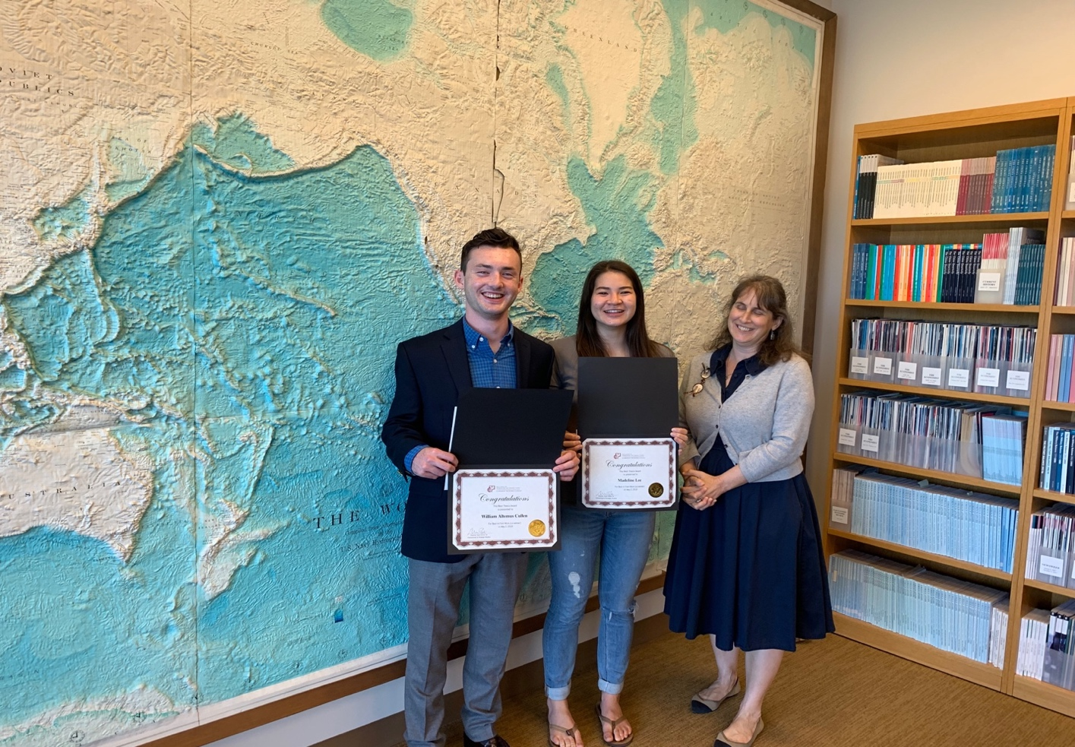
William Cullen and Madeline Lee – (co-winners) Best in Field Work (Advisor: Prof. Sinha & Prof. Taw)
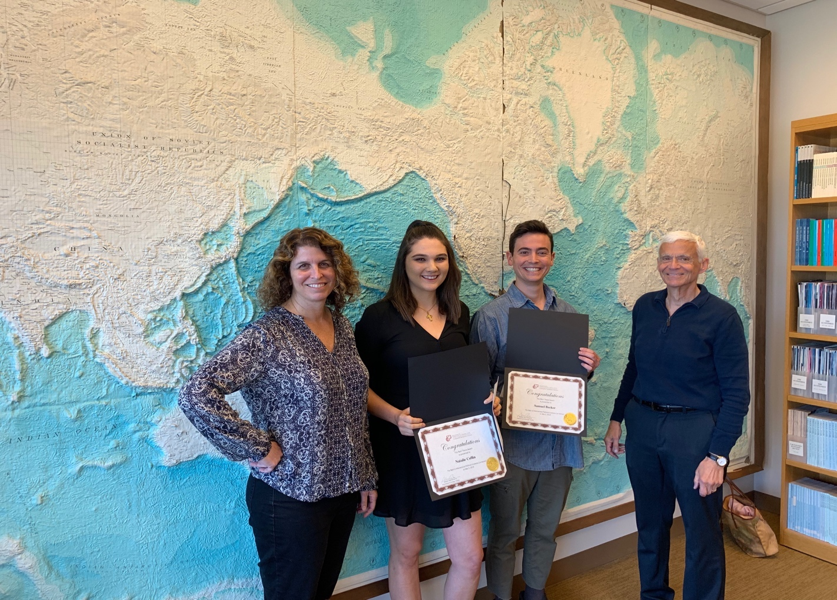Natalie Coffin and Samuel Becker (co-winners) Best in International Political Economy (Advisor: Prof. Appel and Prof. Ascher)

