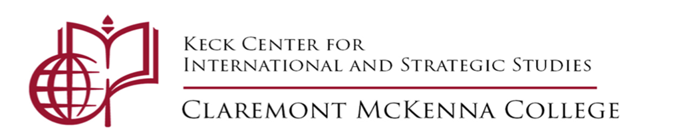

CALL FOR APPLICATIONS

The Keck Center is announcing the following research positions for
Claremont McKenna students.

Keck Center Research Program for the Study of US-Mexican Relations under the Pandemic
Students will participate in a research team studying Mexico’s policy response to COVID-19 and collaborative measures between the United States and Mexico to respond to the crisis. Students will conduct research on this topic under the supervision of Professor Roderic Camp, attending weekly team meetings with Professor Camp on Wednesdays (Time TBA). Student researchers will earn a wage of $15/hour and can expect to devote approximately 5-6 hours/week on this research during the spring semester.

For full consideration, please submit a resume and the following information by Email to the keckcenter@cmc.edu by Thursday, February 11, 2021.

Name ______________________________________ Year_____________________________ Major______________________________________ Email: ____________________________
Relevant coursework ____________________________________________________________________________________________________________________________________________________________
______________________________________________________________________________

Please mark Y or N: (NB: “Yes” answers are not required to be eligible.)
Do you have any Spanish language ability? Y N ____
Are you eligible for Work-Study? Y N _____
Have you been supported by the Keck Center this year? Y N ________
Are you already working as an RA for another institute? _________

Explain why you are interested in this research opportunity (1 paragraph):

