William Zheyuan Shi
Arthur R. Adams Fellow in International Political Economy
Keck Center for International and Strategic Studies
Claremont McKenna College

Would the BRI Fail:
Examining the Emergence of Controversial Projects in the Belt and Road Initiative

I. Introduction
In 2013, Chinese President Xi Jinping announced the ambitious Belt and Road Initiative (BRI) that involves infrastructure development and investment initiatives that span across the Eurasian continent with an expected duration of over two decades. In the Action Plan on the Belt and Road Initiative, China claimed that the BRI “seeks mutual benefit” and “accommodates the interests and concerns of all parties involved, and seeks a conjunction of interests and the ‘biggest common denominator.’” Nevertheless, discontent toward this project began to emerge. China is criticized for exerting debt-for-equity swaps by imposing excessive debt burdens on recipient countries. In December 2017, because of the insurmountable debt burden, the Sri Lanka government gave a 99-year lease to China over its Hambantota port partly because Sri Lanka had an 8-billion debt to China. Some suspect that as a result, on March 6, then-U.S. Secretary of State Rex Tillerson criticized the BRI countries for triggering debt-traps and of “opaque contracts, predatory loan practices, and corrupt deals.” Similar controversies of debt-trap occurred in other regions. In Pakistan, more than 90 percent of the revenue generated at the Gwadar port is going to China for the next forty years. Pakistani experts fear a debt trap due to the rising cost of projects, and extremists groups in Balochistan in the port of Gwadar also launched attacks on Chinese projects. In Laos, the cost of the China-Laos railway exceeded $ 6 billion, which is more than half of Lao’s GDP in 2015. Moreover, the construction of the railway affected more than 4,000 households, who have not received any alternative housing or financial compensation.
It is worth exploring why those projects in the BRI either failed or generated such controversy and discontent. It is debated whether such controversies because of the inherent structure of the BRI, or whether they are avoidable through better planning. Different reasons behind these controversial projects are possible. For example, it is argued that as China domestically has a significant degree of excess productive capacity, China would act as a neo-colonist by exporting the excess productive capacity elsewhere. On the other hand, China and other BRICs countries have an aversion to “the preponderant U.S. and western positions” in the global governance institutions. They are also dissatisfied with unilateral statecrafts, such as sanctions by incumbent powers. Therefore, China and other BRICs countries have interests to both reform the Bretton Woods institutions and create parallel institutions such as the New Development Bank and the Asian Infrastructure Investment Bank, which enabled them to play rule-makers. This paper does not aim to evaluate these claims. It would instead study the controversy of the BRI by examining how policies and investment decisions are made and implemented, and what standards does China value in investing these projects. The attempt to uncover China’s potential objectives or the standards of the BRI investment can shed light on why those projects either failed or generated such significant controversies. The paper first tries to uncover these standards by studying how decisions regarding the BRI are made within the Chinese government. It concludes that it is exceedingly difficult, if not impossible, to do so because of the opaqueness of the decision-making process and functional delegation in the Chinese government. Given such difficulty, the paper attempts to infer China’s standards by using regression analysis. It concludes that China seems to weigh diplomatic purposes, especially those of making more partners, more significantly and more importantly than other metrics related to the success of the BRI, and the heavy emphasis on diplomacy may undermine the quality of some projects.
II. What happens within China’s bureaucracy about the BRI
Why China has to launch the BRI has generated meaningful discussions. It has been hypothesized that China uses it as a channel to mitigate domestic industrial capacity, or as a means to connect western provinces economically. Nevertheless, to examine why some projects in the BRI failed or generated significant controversies, a more proper question to as is how decisions are made in China concerning the BRI, and by what standards do Chinese firms formulate and implement projects. More researches should be conducted to evaluate the connection on the linkage between the BRI and China’s foreign policymaking. Similarly, most research or media reports focus on the effects of the BRI, but it is still necessary to examine what causes such effects. In these respects, it is worth delving into the internal process of policy formulation and standards of specific project implementation.
One way to unveil China’s intentions is to examine the bureaucratic structures and relevant documents to uncover who decides the purposes of the BRI on what grounds. Nevertheless, this approach is arguably infeasible to determine the decision-making and investment criteria because multiple stakeholders are involved in the BRI so that it is not appropriate to consider China as a whole as a rational actor. Moreover, the complex and opaque bureaucracy with functional delegation also makes it difficult to pinpoint the exact standards of the BRI venture. This section would briefly explain the reason for rejecting the inside-put approach and the shift to quantitative methods to infer China’s investment standards.
The existence of multiple stakeholders obscures China’s intentions behind and standards of the BRI. Some argue that a department or ministry dictates policies or directions regarding the direction or policies of the BRI. Nevertheless, the lack of electoral competition does not mean the lack of bureaucratic competition. In this sense, China is never a single and rational actor because it consists of various actors with distinct objectives and interests. Indeed, the National Development and Reform Commission (NDRC), Ministry of Commerce (MOFCOM, and Ministry of Foreign Affairs co-produced the Action Plan on the Belt and Road Initiative, but the language is very vague and broad. Moreover, the specific composition of the group responsible for the framework of the BRI also does not support that the BRI is the product of this or that particular mind or ministry with similar concerns and interests. The lead organizations responsible for the BRI are NDRC, MOFCOM, and Ministry of Foreign Affairs. Nevertheless, the key decisions are decided by the “Small Leading Group,” which consists of five members from the Standing Committee of the Politburo and the State Council. NDRC, MOFCOM, and the Ministry of Foreign Affairs have no power to override the decisions by the Small Leading Group. Although the Chinese Communist Party (CCP) has the final decision-making power related to the BRI, none of the current seven members of the Politburo Standing Committee has the expertise of foreign-policy making, and the scope of Chinese foreign policy has increased. Furthermore, China’s foreign policy has widened its scope, which leaves more room for more stakeholders to influence policy-making. In this sense, policymaking related to the BRI is hardly a straightforward process determined by one ministry but a competitive process with the involvement of different stakeholders.
Under this circumstance, various governmental departments, ministries, and state-owned enterprises have more room to determine or influence the specific measures and implementations of projects. The total conjunction of these stakeholders include but is not limited to the party, different governmental departments, provincial governments, state-owned enterprises (SOEs), and private entities with diverse views and interests. For example, provincial governments in Northeastern provinces such as Hei Longjiang struggle to eliminate their excessive industrial capacities and thus have incentives to participate in the BRI to export their capacity. Even for provinces with less pressure to get rid of their excess capacitycapacities, they still have incentives to participate in the BRI to obtain better governance records. Local officials in China have to demonstrate records of good governance, which typically include economic growth to get promoted. Domestic economic growth had slowed in recent years from 10.6 percent in 2010 to 6.57 percent in 2018, so these provinces have to secure new ways of growth. In this regard, the BRI functions as an alternative approach for officials. As multiple actors participate in the BRI for different reasons and interests, and their specific preferences of financing, investment, and projects also differ, it is unrealistic to discover what weighs the most when China carries the ambitious project abroad just by reading official documents or dissecting the government structures.
Given the multiplicity of stakeholders involved and the unclear functional delegation in the Chinese bureaucracy, it is exceedingly difficult, if not impossible, to uncover what China has in mind. While it cannot be concluded that China does not have a specific foreign-policy goal, such a goal, if it exists, cannot be discovered by reading documents. Given the infeasibility of this qualitative approach, quantitative methods should be used to infer what China values in the BRI, and whether the approach tends to generate the controversies or failed projects.
III. An overview of previous researches
Before discussing the findings of the quantitative analysis, it is necessary to discuss previous researches and the methods adopted in this paper. David Dollar, a senior fellow at John L. Thorton China Center at the Brookings Institution, conducted a regression analysis on China’s overseas lending from 2012 to 2014. By using a database compiled by Dreher et al. (2017) from the AidData, a data lab at the College of William and Mary, he aimed to study the factors that are correlated with China’s development finance. He took two types of financing as the dependent variable: outward direct investment (ODI) and Chinese development finance (CDF), which is loans given to developing countries primarily used for infrastructure purposes. Although China’s Ministry of Commerce publishes data by recipient country on ODI, Dollar points out that half of ODI goes to Hong Kong and thus doubts the accuracy of the data. Dollar chose data from AiData as a better alternative because AidData compiled the data more comprehensively based on every project found. Researchers at AidData use Factiva, a Dow Jones media database that draws on 28,000 media sources. They then searched projects and their relevant information, including funding through the websites of Chinese Embassy and Economic and Commercial Counselor to include projects overlooked by media sources, and finally confirmed the existence of these projects through detailed searches on Google and Baidu. With the database of the AidData, Dollar regressed China’s ODI in 2015 and the CDF from 2012 to 2014 against the log of GDP in 2015, log of population, natural rents as a percentage of GDP, political stability of recipient countries in 2015, rule of law in 2015, and two categorical variables: whether the country is in the BRI, and whether it is a neighboring country of China. The regression result is shown as the following.
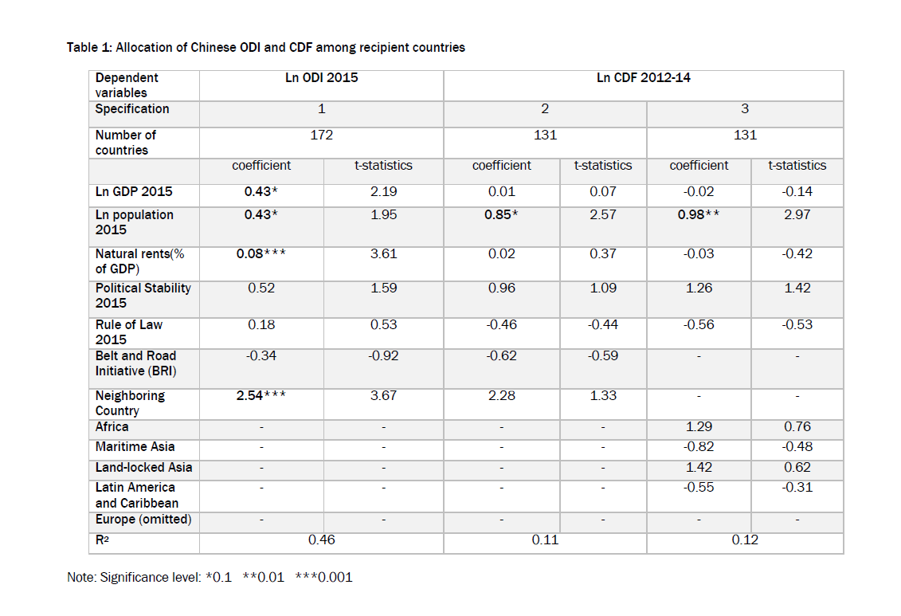

As shown in the result above, Dollar found that China’s ODI is correlated with the GDP and population at a significant level, and China’s CDF is also correlated with a population at a significant level. Nevertheless, this tells very little about China’s standards because it is natural for China to find large or emerging markets with growth potential. China’s ODI is also correlated with the natural rent as a percentage of GDP at a significant level, but the effect is not very large. This might be counterintuitive to some extent because China does not seem to weigh natural resources very heavily according to this data. Moreover, China’s investment appears to be uncorrelated with political stability and the rule of law of the recipient countries. Regarding the political risk, Dollar’s findings conform with the other empirical research, which shows that among the nine out of the top ten recipients of Chinese concessional aid are either outright dictatorships or competitive authoritarian regimes. Thus, Dollar concluded that China’s investment is indifferent to risks.
Nevertheless, some shortcomings of the study should be discussed. First, although Dollar claims that he used the data source from the AidData, the AidData does not include the category of China’s CDF and ODI. The categories included in the database include is only China’s ODA (Official Development Assistance), which China gives to developing countries on a concessional basis, and OOF (Other Official Flows), which China gives on a non-concessional basis. It is unclear whether Dollar re-categorized the data. If he did so, how he categorized the ODI and CDF into ODA and OOF would also be unclear. Second, the periods included in Dollar’s regressions are limited. The BRI officially started in 2013, and the periods that Dollar included in his regressions were from 2012 to 2014 for the CDF and 2015 for the ODI respectively. Nevertheless, some projects in the BRI started as early as 2009, and as the BRI continues, previous and more recent periods should be incorporated. Moreover, the incorporated database should use one type of developmental finance as the dependent variable to track its relations with other metrics of recipient countries.
Despite these shortcomings, Dollar’s research and methodology shed light on the methods to examine what China values the most in its overseas investment. Even if the multiplicity of stakeholders does not constitute a rational mind, the methods can still potentially uncover what these stakeholders converge, or who might be the primary actors in the BRI. Therefore, this paper modifies the Dollar’s methods by trying to mitigate the shortcomings mentioned above and including variables related to China’s diplomatic purposes.
IV. Methods used in this Paper
This paper modifies Dollar’s methods in the following respects. First, it incorporates more periods and conducts regressions from 2000 to 2009, from 2010 to 2016, and from 2000 to 2016. 2009 is chosen as a dividing line because some projects started in 2009 but were later included in the BRI. Moreover, regressing data according to these periods can potentially reveal how China changes its approaches before and after the BRI was launched. Second, for the two types of developmental finance incorporated in the AidData, the paper chooses OOF (Other Official Flows) as the dependent variable. OOF must have the development intent and at least the concessionality of 25 percent, while ODA (Official Development Assistance) has neither requirement of the OOF. Because the research attempts to explore the rise of failed projects and their controversy, no controversy would arise if China voluntarily gives developmental finance via ODA, and no debt is incurred in this process. On the other hand, the non-concessional OOF is mainly for commercial purposes, and only through OOF can a country incur debt to the other. Therefore, it is pointless to explore the relation between ODA and other variables.
The inclusion of variables should also be discussed in this research. This paper includes one special variable related to diplomacy. Diplomatic variables should be included for various reasons. The Beijing Consensus, or China’s mindset or the “intelligible character” of development emphasizes the respect of multiple developmental paths, non-interference, equal status, and sovereign integrity. Given the disparity of the developmental mindsets and the controversial projects, diplomatic variables should be included to explore whether those controversial projects contain the inherent dynamics that seem to uphold or undermine the Beijng Consensus, or can controversy be avoided through management. Moreover, it is argued that China and other developing countries have the common aversion toward dominant of the U.S. and western countries in global governance and the use of unilateral statecrafts such as financial sanctions. As a result, they seek greater autonomy to be the rule makers and thus have the incentive to reform the Bretton Woods institutions and create parallel institutions. In this regard, the BRI could be a key component among China’s aspiration of recognition, autonomy, and voice in foreign relations. Moreover, the competition and hostility between the U.S. and China has been escalating. In the US National Security Strategy, the U.S. lists China as a “strategic adversary,” a competitive and even hostile status unprecedented in history. Under this circumstance, China had further incentives to attract partners in the international sphere to contain U.S. sphere of influence. Because of these concerns of China’s foreign policy and the BRI as a crucial foreign venture, it is proper to include diplomatic variables to examine the potential diplomatic purposes of the BRI, and whether they generate the own contradictions within the project itself.
Some diplomatic variables are considered at the beginning, but only one is included because of the time constraint and the feasibility to acquire data of other variables. The candidates of diplomatic variables include the number of Confucius Institutes, sister cities, total elite visits. Although AidData compiled relevant data for these categories, they do not cover all countries included in the regression analysis for this paper. The number of military conflicts is also considered but eventually rejected because of the time constraint. The diplomatic variable included is a categorical variable of “whether the recipient country has a defense pact with China.” The categorical variable is constructed according to a database that Professor Jennifer Taw at Claremont McKenna College and her research assistants constructed, which include security and defense treaties of major Asian countries from 1979 to 2017. For South and Southeast Asian countries, Taw’s database covers almost all countries identified as suitable to be included in the regression analysis. The paper does not seek.
To make other variables the same or at least roughly the same as those included in Dollar’s research, the paper uses ln GDP, ln Population, Natural Rents as a percentage of GDP, General Government Gross Debt as a Percentage of GDP, Political Stability, Rule of Law, and Democratic Accountability. Among these variables, general government gross debt as a percentage of GDP is newly added to examine whether China is sensitive to the debt level of the recipient countries, given that some projects are criticized for imposing excessive debt burdens. Democratic accountability is newly added to see whether China is neutral to the development path of the recipient countries. Combined with political stability and the rule of law, it can also examine whether China’s investment preferences align with the Beijing Consensus. The data of all these variables are extracted from the database of the World Bank, and political stability, the rule of law, and democratic accountability are extracted from the World Bank’s Worldwide Governance Indicators.
The regression is conducted with a one-year lag. It uses the robust standard error of all variables and corrects for heteroskedasticity. The result of the discussion is shown in the next section.
V. Major findings
The regression results show that China seems to weigh diplomatic considerations very heavily in the proceedings of the BRI. The implicit emphasis on building relations with certain countries might outweigh concerns that are more relevant to the success of projects. This over-emphasis on diplomacy might explain the emergence of certain controversial projects. To put it differently, had China managed to take key factors linked to the success of projects, the controversy might be mitigated, at least to some extent. This section mainly presents the findings of the analysis, connects the general quantitative findings to some specific cases, and explains the shortcomings of the research and some directions of future research.
Two regressions are conducted to explore the trend and changes in China’s overseas investment with 2009 as the dividing period. The first regression with periods before 2009is shown below.

2000-2009
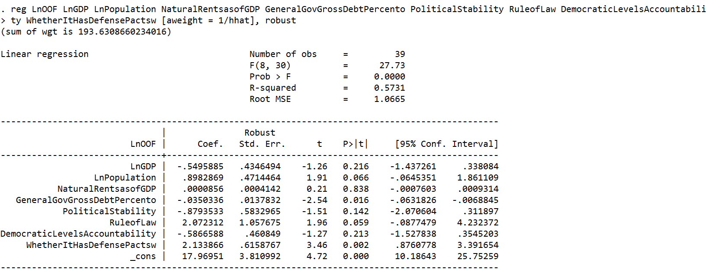

For all significant variables, the effect of general government gross debt as a percentage of GDP is significant but very small. It suggests that even though China might take the debt level into account, other considerations still outweigh the debt level. On the contrary, the effect of the population of the recipient country, the rule of law, and whether the recipient country has a defense pact with China are not only significant but also much larger. In this period, it seems that China might care about the size of emerging markets and also the protection of the investment via the rule of law. Moreover, as China tended to invest in countries with established military relations, it arguably tried to engage with those countries. Nevertheless, China’s style of investment abroad shifted significantly after 2009, when the first BRI project was launched.

2010-2016
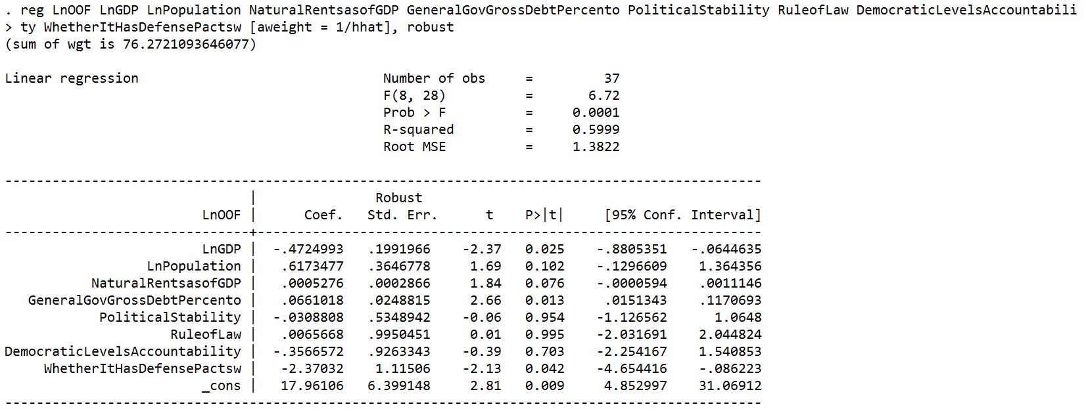

This period contains years from 2012 to 2015, which converge the same periods in Dollar’s regressions. The two regression can be compared. The two results share general agreement, although some slight differences should be noted first. The result of this paper shows that China’s OOF is negatively correlated with the GDP of the recipient country to a significant degree. On the other hand, Dollar’s regression shows that there is a positive correlation between China’s ODI and GDP, but the effect of GDP on CDF from 2012 to 2014 is negligible and insignificant. Likewise, both results show some effects of population on OOF, ODI, and CDF, but the effect in this research is less significant and is valid at 90 percent confidence interval. The difference might be attributed to different periods included in the two regressions, the way that Dollar categorized China’s development finance, and the sample size of the regression database. In terms of other variables, the two results share more convergence. They both show that China’ investment is indifferent to the natural resources of the recipient country. In two regressions, the effects of political stability and the rule of law on China’s overseas investment is negligible.
Moreover, this research has several new findings. It complements Dollar’s findings by showing that China’s investment is also indifferent to democratic accountability of recipient countries. Unlike OOF from 2000 to 2009, China’s OOF from 2010 onwards is almost not correlated with the rule of law, and the rule-of-law variable is insignificant. Interestingly, China’s OOF after 2010 is negatively correlated to a significant degree with the categorical variable of whether the recipient country has a defense pact with China.
The results before and after 2009 should be discussed to evaluate China’s economic, diplomatic, and even geopolitical concerns in the BRI. Before 2009, the rule-of-law variable had a relatively bigger and more significant effect than other variables, but after 2009 the rule of law had a negligible and insignificant effect. Combining with the negligible effect of political stability and insignificant democratic levels after 2009, it seems that the data confirms that China’s overseas investment is indifferent to the quality of political institutions. A more stable political environment, a more robust rule of law, and better democratic accountability can ensure the background condition that protects the investment. In this regard, these data suggest that China does not sufficiently weigh the importance of factors related to institutions that are more linked to the investment success. Moreover, in both periods, China’s investment is generally also indifferent to the gross debt level of the recipient country; The variable of gross debt level is significant but has negligible effects, and China seems to invest slightly more heavily on a percentage basis to countries with heavier debt compared with their GDPs. The indifference might reflect that China does not sufficiently consider factors related to the quality of investment.
The categorical variable constructed from the defense-contract database should be carefully discussed. In the two periods, the effects were the largest among all variables and also very significant, but the direction changed drastically. The positive effect of the defense-pact variable before 2009 suggests that China seemed to engage with countries with established military relations. In contrast, after 2009, China seemed to build ties with countries, which have not signed defense pact. The reason that China displayed such a shift is not clear. The causal inference cannot be drawn from this variable alone because it might be correlated with other variables that are not included in this regression. It is not certain whether China indeed takes the development of military and geopolitical relations very seriously when proceeding with the BRI. Nevertheless, this variable suggests that China’s investment is indeed correlated with one or some diplomatic factors, even if these factors are not by themselves military or military defense. The larger and more significant effect of this variable suggests that China arguably overemphasizes building diplomatic relations with certain recipient countries, but it downplays the importance of other factors more relevant to the success of the overseas investment. The over-emphasis of diplomatic concerns and underestimation of other factors arguably can explain or partly explain the emergence of failed and controversial projects in the BRI.
Before discussing the results and the implications, it is necessary to mention the limits of the methodology. The sample size in this research is limited because of the constraint of individual effort. Although the sample is large enough for the law of large numbers to hold, a larger size is more suitable to make the results more accurate and comprehensive. It is advisable to conduct quantitative analysis during later phases of the BRI to update results. Moreover, the construction of a categorical variable rather than a continuous variable is for practical purposes. The effect of 1 might be exaggerated because of the categorical variable. Nevertheless, given that China did not have far fewer defense pacts with countries in the Eurasian continent, constructing a continuous variable would produce many zero values, which might also exaggerate the effect of 0. In this regard, more variables related to diplomacy should be included to refine the methods.
VI. Discussions of results
China’s OOF displays a shift to countries without defense pact. This shift requires further explanations. China may or may not view the building of military relations as one metric in the BRI, but it is unlikely to be the only metric that matters. One hypothesis that can explain this shift is China’s incentives to secure ports, build new sea lanes, and foster economic and political relations with countries, particularly those with ambivalent attitudes to the U.S. and China.
The diplomatic concerns to find new partners and secure ports is one hypothesis of China’s underlying concerns and explanation of China’s shift of investment. Future researches should test this hypothesis and shed light on the direction of further research as the BRI proceeds in the future.
Regardless of China’s specific metrics, the over-emphasis on this or that standard outweigh other considerations more critical to the success of BRI projects. The pursuit of these standards may undermine the diplomatic goals and sustainability of some projects. A report by the Center of Global Development concludes that at least eight countries are vulnerable to excessive debt burden because of BRI-related financing.” Among these countries are Djibouti, the Maldives, Laos, Montenegro, Mongolia, Tajikstan, Kyrgyz Republic, and Pakistan. The sole pursuit of diplomatic goals may render the construction of these projects counterproductive. Bangladesh in 2015 negotiated with China for funding of the Matarbari Port, but the funding was very unacceptable such that Bangladesh turned to Japan to finance the project. Moreover, the controversies of those projects may also provoke international criticism counterproductive to China’s potential diplomatic concerns, ranging from Sri Lanka’ handover of the Hambantota and the displacement of the local population in Laos due to the China-Laos railway. To ensure the sustainability of the BRI and make it work toward China’s diplomatic purposes, whatever they are, other important metrics crucial to the success of investment should have proper weight and coexist with the diplomatic and geopolitical concerns should coexist.
VII. Conclusion
The bureaucratic complexity and opaqueness make the research use a quantitative approach to infer China’s possible standards or factors related to the standards. The regression analysis shows that China’s Other Official Flows are significantly correlated with whether China has at least a defense pact with the recipient country. Although a causal inference cannot be drawn from this analysis alone, it suggests that China might overemphasize some diplomatic concerns but underestimate the importance of factors more related to the success of projects in the BRI. The sole emphasis on diplomacy has a counterproductive effect that tends to undermine the sustainability of BRI projects. Future research can conduct quantitative analysis by using a larger sample and incorporating more variables to refine the results.

Bibliography
“Brookings experts on Trump’s National Security Strategy.” The Brookings Institution. December 21, 2017, https://www.brookings.edu/research/brookings-experts-on-trumps-national-security-strategy/. Accessed January 9, 2019.
Chatzky, Andrew and James McBride. “China’s Massive Belt and Road Initiative.” The Council on Foreign Relations, last updated May 21, 2019, https://www.cfr.org/backgrounder/chinas-massive-belt-and-road-initiative. Accessed January 10, 2019.
Custer, Samantha, Brooke Russell, Matthew DiLorenzo, Mengfan Cheng, Siddhartha Ghose, Harsh Desai, Jacob Sims, and Jennifer Turner, “Ties That Bind: Quantifying China’s public diplomacy and its “good neighbor” effect,” Executive Summary. AidData & Center for International and Strategic Studies & China Power & Asia Society Policy Institute. 1-8. June 27, 2018, https://www.aiddata.org/publications/ties-that-bind. accessed January 9, 2019.
Dollar, David. “The AIIB and the “One Belt, One Road.” The Brookings Institution. Summer 2015, https://www.brookings.edu/opinions/the-aiib-and-the-one-belt-one-road/, accessed January 8, 2020.
Dreher, Axel, Andreas Fuchs, Bradley Parks, Austin M. Strange, and Michael J. Tierney. “Aid, China, and Growth: Evidence from a New Global Development Finance Dataset.” AidData. October 2017, 1-61, https://www.aiddata.org/publications/aid-china-and-growth-evidence-from-a-new-global-development-finance-dataset.
Full text: Action plan on the Belt and Road Initiative, http://english.www.gov.cn/archive/publications/2015/03/30/content_281475080249035.htm.
GDP growth (annual %) – China, The World Bank, https://data.worldbank.org/indicator/NY.GDP.MKTP.KD.ZG?locations=CN, accessed January 8. 2020.
Hurley, John, Scott Morris, and Gailyn Portelance, “Examining the Debt Implications of the Belt and Road Initiative from a Policy Perspective.” Center for Global Development, March, 2018. 1-37.
Khattak, Daud. “Belt and Road Tests China’s Image in Pakistan.” Foreign Policy, October 10, 2019, https://foreignpolicy.com/2019/10/10/belt-and-road-tests-china-image-pakistan-imran-khan-xi-jinping-diplomacy-special-relationship/. Accessed January 8, 2020.
Kleven, Anthony. “Belt and Road: Colonialism with Chinese Characteristics.” The Lowy Institute. January 8. 2019, https://www.lowyinstitute.org/the-interpreter/belt-and-road-colonialism-chinese-characteristics, accessed January 8, 2020.
Li, Eric X. “The Life of the Party.” Foreign Affairs, January/February 2013, https://www.foreignaffairs.com/articles/china/2012-12-03/life-party, accessed December 16, 2019.
Macan-Markar, Marwaan. “China’s Belt and Road rail project stirs discontent in Laos.” Nikkei Asian Review, March 15, 2018, https://asia.nikkei.com/Politics/China-s-Belt-and-Road-rail-project-stirs-discontent-in-Laos2, accessed January 8, 2020.
“Nadège, Rolland On the Potential Backlash against The Belt and Road Initiative,” interviewed by William Shi. Asia Experts Forum. March 8, 2018, http://asiaexpertsforum.org/nadege-rolland-potential-backlash-belt-road-initiative/. Accessed January 8. 2019.
Pei, Minxin. “A play for global leadership.” Journal of Democracy, April 2018, 29(2), 37-51, doi:http://dx.doi.org.ccl.idm.oclc.org/10.1353/jod.2018.0023.
Roberts, Cynthia. “The BRICS and Collective Financial Statecraft.” New York, N.Y.: Oxford University Press, Kindle Edition. 1-23.
Stacey, Kiran. “China signs 99-year lease on Sri Lanka’s Hambantota port.” The Financial Times, December 11, 2017, https://www.ft.com/content/e150ef0c-de37-11e7-a8a4-0a1e63a52f9c. Accessed January 8, 2019.
“The Beijing consensus is to keep quiet.” Economist. May 6, 2010 edition, https://www.economist.com/asia/2010/05/06/the-beijing-consensus-is-to-keep-quiet. accessed January 10, 2020.

Andrew Chatzky and James McBride, “China’s Massive Belt and Road Initiative,” The Council on Foreign Relations, last updated May 21, 2019, https://www.cfr.org/backgrounder/chinas-massive-belt-and-road-initiative, accessed January 10, 2019.
Full text: Action plan on the Belt and Road Initiative, http://english.www.gov.cn/archive/publications/2015/03/30/content_281475080249035.htm, accessed January 8, 2019.
Kiran Stacey, “China signs 99-year lease on Sri Lanka’s Hambantota port,” The Financial Times, December 11, 2017, https://www.ft.com/content/e150ef0c-de37-11e7-a8a4-0a1e63a52f9c, accessed January 8, 2019.
“Nadège Rolland On the Potential Backlash against The Belt and Road Initiative,” Asia Experts Forum, March 8, 2018, , accessed January 8. 2019.
Ibid.
Daud Khattak, “Belt and Road Tests China’s Image in Pakistan,” Foreign Policy, October 10, 2019, https://foreignpolicy.com/2019/10/10/belt-and-road-tests-china-image-pakistan-imran-khan-xi-jinping-diplomacy-special-relationship/, accessed January 8, 2020.
Nadège Rolland Interview.
Marwaan Macan-Markar, “China’s Belt and Road rail project stirs discontent in Laos,” The Nikkei Asian Review, March 15, 2018, https://asia.nikkei.com/Politics/China-s-Belt-and-Road-rail-project-stirs-discontent-in-Laos2, accessed January 8, 2020.
Anthony Kleven, “Belt and Road: Colonialism with Chinese CharacteristicS,” The Lowy Institute, January 8. 2019, https://www.lowyinstitute.org/the-interpreter/belt-and-road-colonialism-chinese-characteristics; David Dollar, “The AIIB and the “One Belt, One Road,’ The Brookings Institution, Summer 2015, https://www.brookings.edu/opinions/the-aiib-and-the-one-belt-one-road/, accessed January 8, 2020.
Cynthia Roberts, The BRICS and Collective Financial Statecraft, New York: N.Y., Oxford University Press. Kindle Edition. 4.
Ibid.
Chatzky and McBride.
Yu, 3.
Full text: Action plan on the Belt and Road Initiative.
Yu, 6.
Ibid., 7.
Ibid., 5.
Ibid., 6.
Ibid.,
Ibid., 3.
Li, Eric X. “The Life of the Party.” Foreign Affairs, January/February 2013, https://www.foreignaffairs.com/articles/china/2012-12-03/life-party, accessed December 16, 2019.
GDP growth (annual %) – China, The World Bank, https://data.worldbank.org/indicator/NY.GDP.MKTP.KD.ZG?locations=CN, accessed January 8. 2020.
David Dollar, 6.
Ibid.
Ibid.
Ibid.
Ibid.
Ibid., 26.
Minxin Pei, A play for global leadership, Journal of Democracy, April 2018, 29(2), 40, doi:http://dx.doi.org.ccl.idm.oclc.org/10.1353/jod.2018.0023.
Axel Dreher, Andreas Fuchs, Bradley Parks, Austin M. Strange, and Michael J. Tierney, “Aid, China, and Growth: Evidence from a New Global Development Finance Dataset,” AidData, October 2017, 2, https://www.aiddata.org/publications/aid-china-and-growth-evidence-from-a-new-global-development-finance-dataset.
“The Beijing consensus is to keep quiet,” Economist, May 6, 2010 edition, https://www.economist.com/asia/2010/05/06/the-beijing-consensus-is-to-keep-quiet, accessed January 10, 2020.
Roberts, 4.
Ibid.
“Brookings experts on Trump’s National Security Strategy.” The Brookings Institution, December 21, 2017, https://www.brookings.edu/research/brookings-experts-on-trumps-national-security-strategy/, accessed January 9, 2019.
Samantha Custer, Brooke Russell, Matthew DiLorenzo, Mengfan Cheng, Siddhartha Ghose, Harsh Desai, Jacob Sims, and Jennifer Turner, “Ties That Bind: Quantifying China’s public diplomacy and its “good neighbor” effect,” Executive Summary. AidData & Center for International and Strategic Studies & China Power & Asia Society Policy Institute. June 27, 2018, https://www.aiddata.org/publications/ties-that-bind, accessed January 9, 2019.
John Hurley, Scott Morris, and Gailyn Portelance, “Examining the Debt Implications of the Belt and Road Initiative from a Policy Perspective,” Center for Global Development, March, 2018, 11.
Ibid.
Nadège Rolland interview.

