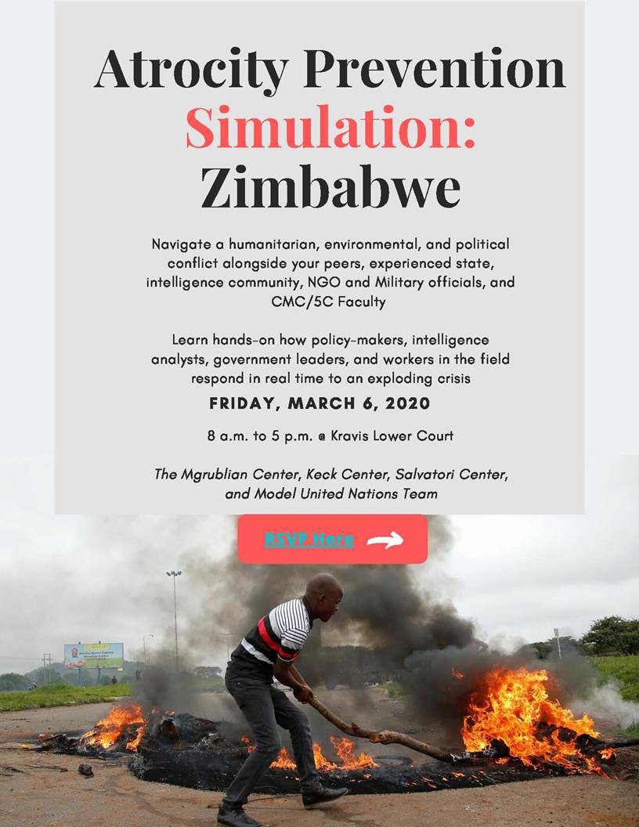
Friday March 6th 8am – 5pm
Kravis Center, Lower Court CMC

Food Provided!

RSVP Now!

Sponsored by:

Mgrublian Center for Human Rights Salvatori Center for Individual Freedom Keck Center for International & Strategic Studies

Navigate a “real life” international crisis with an amazing team of practitioners:

- James Finkel, former CIA officer, War Crimes Investigations, and Atrocity Prevention Board subgroup member (Washington, DC)
- Richmond Blake, Director of Policy and Advocacy, Mercy Corps (Washington, DC)
- Cecil Blake, Former Cabinet Minister of Information and Broadcasting (Sierra Leone); founding member of AFRICA leadership forum
- Tetsushi Ogata, Professor of Peace and Conflict Studies (Soka U); former director of Genocide Prevention Program (George Mason University)
- Jennifer Miller (CMC'97), Deputy Assistant Secretary of the Air Force for Installations, Pentagon (Washington, DC)
- Larissa Peltola (CMC ’18), Legal Researcher, Haysbert/Moultrie LLC (Los Angeles)
- Jasmine Shirey (CMC'18), Program Officer, Forum for African Women Educationalists, Elbaz Post-Graduate Fellow (Harare, Zimbabwe)
- Evan Wollen, Assistant Director of Sponsored Internships, CMC; Professor of Military Science, CMC; Veteran, Operation Iraqi Freedom

Questions? Contact Kirsti Zitar, kzitar@cmc.edu or Jenny Gurev, jgurev20@cmc.edu

