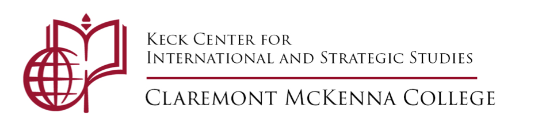
To All CMC Students:
New Course: Race, Gender, and Identity in International Relations (GOVT157S ACM)
The Keck Center is sponsoring a new research and study program which includes individual research projects, group discussions, guest speakers, and professional mentorship. The program offers one course academic credit, faculty and professional mentors, and three seminars with guest speakers. Students register for a special topics course taught by Professors Taw and Appel entitled Race, Gender, and Identity in International Relations.
The program has three main components:
1. students will be invited to work independently or in small groups on a project they develop with a faculty reader. That project will address some aspect of race, gender, and identity in IR and can be a research paper, an op-ed and supporting research/evidence, a news article for publication in a media outlet and supporting research/evidence, a journal article, a policy proposal, a series of mini-papers, a podcast... essentially, whatever the students and their reader agree upon. The final product should be the equivalent, by some measure, of a 35 page research paper.
2. students will convene as a group to discuss assigned readings on race, gender and identity in IR and to meet virtually with three guest speakers over the course of the semester to talk to the students about issues of race, gender, and identity in IR as, respectively, a discipline, a vocation, and a practice.
3. students will be assigned to a CMC alumnus working in some aspect of IR as a mentor. Those mentors will be links to real world application of an IR degree, will talk to the students about their own experiences as women and/or BIPOC post-CMC, and will discuss everything from graduate school opportunities and expectations to IR-related professional options. Ideally, these people will continue to be part of the student's network and support system well after Fall 2020.
To participate in the program:
- students will apply to the Keck Center and enroll in the one credit course with instructor permission
- students who are accepted will be invited to an introductory meeting to discuss their options (working independently/in groups; the various possible products) and be matched with a faculty reader.
- students will convene as a group twice in September to discuss assigned readings, and three times in October and November for guest speakers and once more at the close of the semester to present their work. Students meet about three times per month with their faculty reader to develop and discuss individual/small group research projects.
Learning outcomes: students will develop expertise on some aspect of race, gender, and identity in International Relations, deepening their overall understanding of the discipline and the applications of its tenets and theories; they will hone their research, analysis, and writing skills; they will be introduced to the nexus of academia and policy; they will receive support and advice from CMC who have become practitioners. Please click HERE for the form due Wednesday, July 29, 2020. Submit the form to ghan@cmc.edu
- Course credit: 1 CR
- Course time: Wednesday's at 4:15 pm

