The Interoceanic Multimodal Corridor Megaproject: A Failing Attempt at Developing El Sur de México

International Political Economy Fellowship Summer 2020
Author: Angel Ornelas
Advisor: Professor William “Bill” Ascher

Background

On June 14, 2019, the Mexican Federal Official Gazette published a decree creating the Interoceanic Multimodal Corridor Megaproject. This is in response to Mexico’s unequal development, with inequalities among regions and social groups increasing. To address growing unrest in southern Mexico, the Mexican government has proposed heavy concentration in 79 municipalities (33 in Veracruz and 46 in Oaxaca). The Interoceanic Multimodal Corridor, labeled as a project with the potential to boost growth of the regional economy, is a major component of Mexican president Andrés Manuel López Obrador’s (AMLO) National Plan for Development (PND) 2019-2024. This megaproject is shaped by the Guiding Principles of the PND 2019-2024: Economy for Well-being; and the market does not replace the State and does not leave anyone behind. The Principles propose that to ensure the economic well-being of all, the Mexican government aims to close regional inequality gaps and promote balanced, sustainable and inclusive development in the Isthmus region.
The premise of the Interoceanic Multimodal Corridor Megaproject is that it will y strengthen domestic markets and generate regional production chains that allow the well-being of the population and regional growth to be promoted, entailing a major change in economic activity. The development project has five distinct goals: (1) strengthen the isthmus’s capacity to generate jobs and income for the population with infrastructure, (2) promote a new way of seeing development by balancing the economic and social aspects of the region, (3) serve marginalized communities, (4) conserve, restore, and increase natural resources and biodiversity, and (5) reinforce culture, regional identity, and social stability.

Policy Goal 1 - Strengthen the social and productive infrastructure in the Isthmus of Tehuantepec region
Increased infrastructure to allow for greater territorial, economic and social cohesion, providing accessibility to and from southern Mexico, and improving the quality of life of the communities affected by impoverishment. The premise is that this infrastructure would not only increase productivity by creating jobs and reduces production costs, but also expand commercial activity, private investment, capital accumulation, and social development. The region of the Isthmus of Tehuantepec presents a significant lag in terms of social infrastructure. According to data published by CONEVAL (National Council for the Evaluation of Social Development Policy) as a result of the latest multidimensional measurement of municipal poverty, 45.5 percent of the population in the Isthmus of Tehuantepec lack basic housing services (which is more than double the national average which is 19.3 percent). That is, this population presents at least one of the following characteristics in their homes: 1. water is obtained from a well, river, lake, stream, pipe; or, water is obtained by hauling it from another home, or from the public tap or hydrant; 2. lack of drainage service; 3. lack of electricity; and 4. fuel used for cooking or heating food is wood or charcoal without a fireplace.
Faced with this regional problem and within the framework of the guiding principle of the 2019-2024 PND under the slogan "Leave no one behind, leave no one out,” the infrastructure investments are aimed at triggering economic development in the Isthmus of Tehuantepec, decreasing the inequality gap with respect to other regions of the country. The premise is expanded, and modernized equipment and basic infrastructure would achieve increased connectivity throughout the country and effectively meet the needs of infrastructure services of the Isthmus region. Finally, the adequate availability of infrastructure, as well as the expanded availability of essential services, will help the Isthmus Region develop competitive advantages and achieve a greater degree of economic specialization. The development of road networks, port infrastructure, expanded cargo transport services, expansion of energy, telecommunications, and drinking water supplies and sanitation systems are deemed essential to the adequate development of the Isthmus Region. Of the 79 municipalities that make up the Isthmus of Tehuantepec, 88 percent of economic activity is concentrated in three (Salina Cruz, Minatitlán and Coatzacoalcos). This underscores the importance of implementing development strategies in support of economic activities with greater diversified added value for the municipalities of the Isthmus.

Policy Goals 2 and 3 - Promote a new model of economic growth for development for the benefit of the population of the Isthmus of Tehuantepec and ensure the articulation of emerging actions for the population living in extreme poverty in the Isthmus of Tehuantepec
Since the end of the 1980s, regional and local development programs became prioritized by the Mexican presidency. The need to expand the participation of underdeveloped regions in economic and social development have led local governments to assume the responsibility of promoting and leading the process of social agreement among various regional actors to design and implement development plans and actions aimed at taking advantage of endowments. The emergence of globalized economies in Latin America and greater democratization have led the state to direct investment and economic activity, public and private, towards economically lagging and socially marginalized regions. The Isthmus of Tehuantepec region, with its 46 municipalities in Oaxaca and 33 in Veracruz, presents a significant lag in terms of economic growth and wealth distribution. The population that inhabits the region amounts to 2.4 million people, of whom 789,000 are employed in the formal sector. Furthermore, 60.6 percent of the population live under the poverty line.
Although southern municipalities such as Salina Cruz and Coatzacoalcos have developed large productive infrastructure projects, 13 of 79 municipalities that make up the Isthmus report no workers to the IMSS (Mexican Social Security Institute). Three municipalities with the highest prevalence of extreme poverty in the region are Oaxacan: San Mateo del Mar (63.9 percent); San Lucas Camotlán (63.8 percent) and Santa María Guienagati (59.8 percent). This implies that for these municipalities, six out of ten inhabitants are in extreme poverty. Likewise, in 15 municipalities in the region, the prevalence of extreme poverty is between 30 percent and 59 percent; while 45 municipalities, the proportion of extreme poverty is between 10 percent and 29 percent, and finally, there are only 13 municipalities below ten percent of extreme poverty.
Thus the Interoceanic Multimodal Corridor Megaproject is proposed to serve two fundamental purposes: to increase the demand for labor and local production, and to increase the supply of economic and social infrastructure, through actions aimed at establishing the infrastructure required to turn impoverished regions into attractive regions for private capital, national and foreign.
Policy Goal 4 - Increase biodiversity, and improve water, soil and air quality with a sustainable approach in the region of the Isthmus of Tehuantepec.
The proposed initiative must be assessed in terms of its possible impact on the environment, compared to alternative infrastructure developments, as well. The Isthmus of Tehuantepec region has problems of environmental deterioration that require solutions in the short, medium, and long term. The wealth of natural resources that are still distributed in the region are essential for the Isthmus’s economic development. The vast amount of rich natural resources is a consequence of the geological history of the region, which allowed for the formation of wide plains, mainly in Veracruz, and mountainous areas in Oaxaca. This diversity allowed for the current presence of tropical and temperate climates that are the basis of the Isthmus’s biological diversity. Mangroves have a fundamental role in flood control and constitute a barrier against hurricanes and contribute to the control of erosion and recharge of aquifers.
Forest areas are an important refuge for birds and fauna. Due to deforestation and habitat disturbance, many species have disappeared from the region. Finally, the region has a wide variety of water resources. The Coatzacoalcos river, with a length of 375 km which constitutes the fourth largest current in the country. The stream is made up of three main parts: Uxpanapa, Cuachapa, and Cahuapan. In Salina Cruz, the Los Perros River and the Tehuantepec River stand out. The preservation of rivers and aquifers in the region is essential for the development of all economic sectors and the progress of the population. Wetlands also play an essential ecological function as a purifier and exporter of large volumes of organic matter to estuaries and coastal areas, thanks to the slow movements of water, as well as bacterial decomposition. The proper functioning of swamps is vital for the development of commercially important marine species and for the existence of plant communities of ecological importance subject to protection policies (mangrove, low flood forest, palm groves and hydrophytic vegetation).
Policy Goal 5 - Protect, reinforce and disseminate the linguistic and cultural diversity, memory and cultural heritage of the indigenous, Afro-Mexican and other peoples of the Isthmus of Tehuantepec, through actions that guarantee their participation and cultural rights
The Isthmus of Tehuantepec is a region of enormous cultural diversity marked by the presence of indigenous communities such as Binnizá (Zapoteco), Ayuuk (Mixe), Zoque, Ikoots (Huave), Chontal, Chinanteco, Mazateco and Mixteco. All these peoples, to a greater or lesser extent, have faced adverse scenarios throughout the centuries to maintain their lands, territories and natural resources as part of their heritage. In the Isthmus region, around 834,000 people consider themselves indigenous and just over 341,000 speak some indigenous language. It is critical to guarantee indigenous peoples and communities their right to participate in decision-making on matters that impact them, whether in their use of lands, territories, or natural resources. Since the 16th century, the Isthmus of Tehuantepec has been the object of multiple development proposals, all of them with the purpose of benefiting large investors and the peoples of the Isthmus region. Although the communities have had a permanent existence in these lands, they have rarely been consulted or have established spaces for dialogue with their representative bodies, a situation that has generated an atmosphere of confrontation with government institutions. The claim by the government is that the Interoceanic Multimodal Corridor Megaproject will have a central focus on indigenous communities based on cultural specificities, achieving the well-being of indigenous peoples, and respect for fundamental rights and a fair distribution of benefits. This would require continuous dialogue with the indigenous peoples and communities located in the project's area of ​​influence, to incorporate their vision of development into the project and design mechanisms that guarantee a fair and equitable distribution of resources. The Ministry of Culture and the National Institute of Indigenous Peoples is to be assigned a significant role in monitoring and ensuring that indigenous communities partake in the megaproject’s execution and decide their own priorities for development.

Flaws in Policy Rationales
This megaproject is fueled by four distinct rationales. In terms of the technological rationale, the development of the Isthmus of Tehuantepec would allow for the immense construction of and modernization of existing infrastructure. The following are the main technological advances that are highlighted by the Mexican government: the modernization of the Tehuantepec Isthmus Railway (FIT) would enable rail transportation to increase speed and travel and lower transportation costs; the modernization of commercial ports in Oaxaca and Veracruz would offer efficient cargo, transportation, warehousing, packaging, and various logistics services; the modernization and complementation of the primary and secondary road networks would offer better infrastructure to ports; the strengthening of digital connectivity networks would allow greater connectivity of the region with the entire world to facilitate its operation and intercommunication at a global level; the construction of a gas pipeline will allow communities in the region to be supplied, covering the demand for gas for homes, businesses, and industries of the Isthmus; constructing roads and increasing access to clean drinking water and electricity will allow for better quality of life. These developments represent “rich opportunities for pushing the boundaries for what technology can do,” dramatically changing the ways in which communities in the Isthmus region operate. Moreover, the creation of interoceanic passage is claimed to be an immense technological accomplishment, marking an important achievement that complements the Isthmus region’s geography.
For AMLO, the construction of an oceanic corridor in the Isthmus region represents an important political rationale that serves to legitimize MORENA’s (National Regeneration Movement) national economic agendas, ensure the continuance of MORENA leaders in national politics, and challenge America’s presence in global markets. Moreover, by cementing MORENA’s economic grip on development projects, rival political parties will have a difficult time demotivating stakeholders from not continuing with the Interoceanic Multimodal Corridor Project.
The economic rationale, on the other hand, is unclear. The Mexican government has not released information on the potential return on investment rate, nor has it disclosed its partnerships or co-loaning actors. Also, the aesthetic rationale for this development project is also unclear, since there have not been any rough sketches that are available to the public. There is a lack of information on whether or not there will be an aesthetic contribution to Mexican heritage or to the surrounding environment where the megaproject will be constructed.

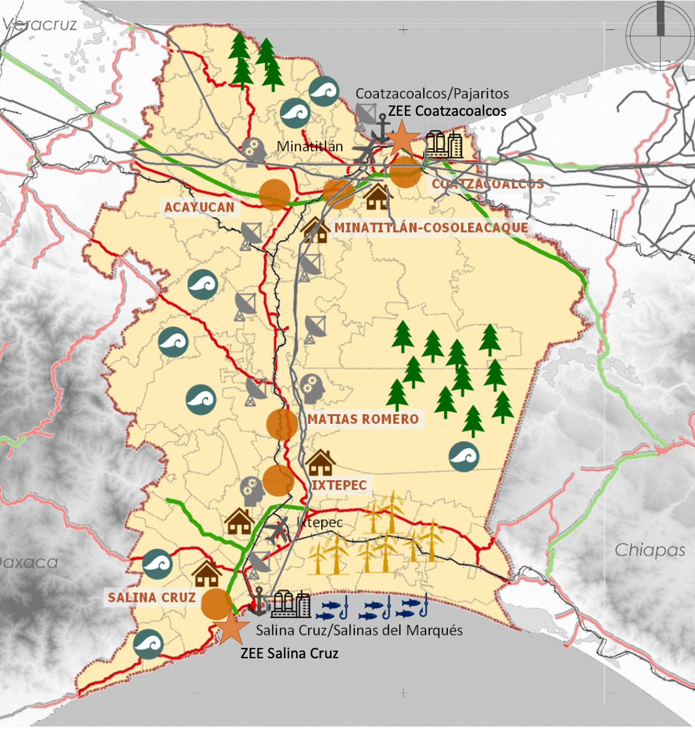

Figure 1 - Overview of Interoceanic Multimodal Corridor Development Project
(Source: Secretaría de Hacienda y Crédito Público)
Project Components
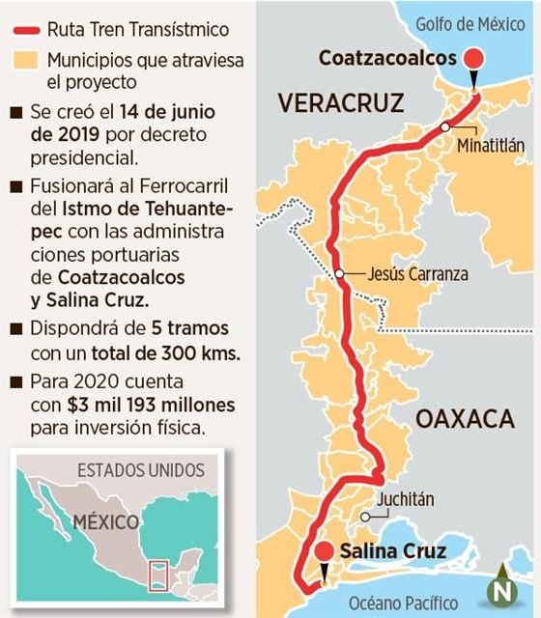
Transisthmian Railway

Figure 2 - Policy Goals of Transisthmian Railway
(Source: Mural)

According to the Mexican government, the Transisthmian Train project plays an integral role in the Program for the Development of the Isthmus of Tehuantepec, an instrument that would enable the extended flow of goods transported to and from the ports Coatzacoalcos and Salina Cruz. A trunk road extending from Medias Aguas, Veracruz will connect Salina Cruz port to Coatzacoalcos port, forming a total length of 303,304 km.
Ports
The following ports will be modernized and expanded: Salina Cruz (a major seaport on the Pacific coast of the Mexican state of Oaxaca) and Coatzacoalcos (a major port city in the southern part of the Mexican state of Veracruz). At the Salinas Cruz site, existing equipment will be modernized and building a container terminal with automated technology, allowing for more efficient loading, unloading, and transportation of cargo. Moreover, dredging will be conducted in an effort to remove any and all sediments impeding the rehabilitation of the 316 km rail line between the Salina Cruz port in Oaxaca and Coatzacoalcos port in Veracruz.
Roads
To improve connectivity throughout Oaxaca, the Mitla-Tehuantepec Highway will be completed. The claim is that this will allow underserved, rural areas of Oaxaca to better connect with existing highways, allowing for greater access to major cities, access to essential services, and increased movement of goods. The highway project will widen a 104.2 km stretch of the Oaxaca-Puerto Escondido-Huatulco road, and finish existing work on the 104.3 km Barranca Larga-Ventanilla motorway linking Oaxaca City to the Pacific Coast. The Mexican government correctly points to the need for small roads and repairing poor roads, which are detrimental to the easy flow of goods.
Other Forms of Infrastructure
In addition to the construction of roads, the Interoceanic Multimodal Corridor project claims to do the following: strengthen educational infrastructure by building new and modernizing existing schools and universities; improvement of digital connectivity, access to internet and cellular telephony; promote research and technological development by constructing innovation centers; develop energy infrastructure, primarily non-renewable sources; promote public health, education, and food programs; strengthen public service infrastructure: water, electricity, energy, drainage, and solid waste systems; strengthen housing infrastructure and urban facilities; and minimize negative environmental impacts.
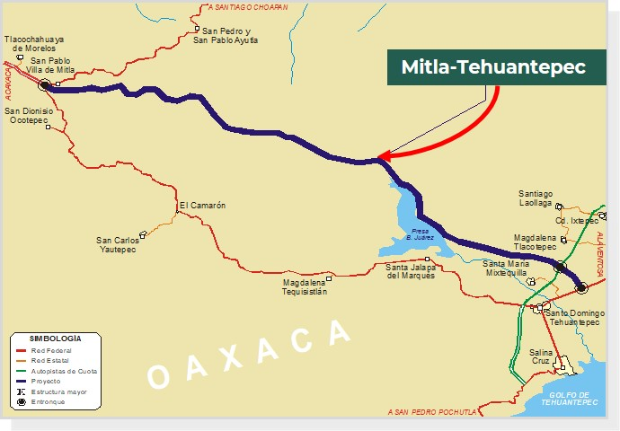

Figure 3 - Mitla Tehuantepec Highway
(Source: https://www.fonadin.gob.mx/fni2/fp52/)

Indigenous Resistance and Government Consultations
According to the Mexican government’s press releases, “[t]he process of free, prior and informed consultation to the indigenous peoples and communities of the Isthmus of Tehuantepec is headed by the Ministry of Finance and Public Credit (SHCP), through the decentralized public body Corredor Interoceanico del Istmo de Tehuantepec as the responsible authority; the Ministry of the Interior (Segob) as the guarantor body; and INPI, in its capacity as technical body. The Government of Mexico reiterates its commitment to maintain permanent dialogue with the indigenous peoples of the Isthmus of Tehuantepec.”
Despite these public declarations of cooperation and consensual consultation with indigenous communities affected by the Interoceanic Multimodal Corridor Megaproject, there has been extensive backlash by community members and human rights defenders. Although the original claim by the Mexican government is that these consultations with indigenous communities would be with cultural governmental bodies, the Ministry of Finance and Public Credit is conducting the community consultation work. This major inconsistency and blatant disregard are indicative of the Mexican government’s uncooperative nature and nontransparent execution of the megaproject. Among the human rights defenders who have shed light on this subject and spoken against the megaproject’s continuation are anthropologists from the National Institute of Anthropology and History, agricultural engineers from the Autonomous National University of Mexico, and representatives from the Tepeyac Centre of Human Rights of the Isthmus of Tehuantepec, A.C., the General Coordination of the Asamblea de Pueblos Indígenas del Istmo Oaxaqueño en Defensas de la Tierra y el Territorio, the Department of Indigenous Rights of the National Institute of Indigenous Peoples, and the Department of Forced Displacement of the Mexican Commission for the Defense. Advocates and community leaders argue that the federal government should take into consideration the resistance of indigenous communities, employ consultations with indigenous languages, and align federal goals of development with the ideals of development expressed by affected communities.
More importantly, the Interoceanic Multimodal Corridor Megaproject would severely damage the biodiversity and bodies of water that exist in the Isthmus region. The megaproject would open up mining operations, further consolidating extensive environmental damage. In fact, according to indigenous community leaders, the Ministry of Economic Affairs has already conceded 7,000 hectares, to Canadian mining companies Minaurum Gold and Gold Copper. More troubling are speculations of mining and fracking companies partnering with cartels to eliminate any and all indigenous resistance to extraction efforts. Josefa Sánchez Contreras, a young Zoque participant in a local agrarian commission in San Miguel Chimalapa, Oaxaca, the partnership between Canadian mining companies and the Isthmus of Tehuantepec Development Project is extremely concerning:
“The two concessions that currently exist, for just over 7,000 hectares, are by the company Minaurum Gold and Gold Copper, Canadian companies, which for several years the Ministry of Economy granted them the concession without any prior consultation or notice. to our indigenous community.”

Moreover, the Mexican government has not published any data on the potential negative environmental impacts of the megaproject. Despite this, it is safe to say that the merging of two bodies of water (Pacific Ocean and Gulf of Mexico) will cause some form of disruption in biodiversity and ecological systems.
A Mega Project Failure
Although construction of the project has been delayed due to COVID-19, operations may start in 2020. The total cost of the project is expected to be about 46.4 billion Mexican pesos (US $360 million), although this estimate is very likely to be greater due to the slow nature of megaproject executions. Within one-to-two years, the Mexican government expects the development of basic infrastructure, ports, and railway works to be finalized. Within ten years or more, the Mexican government expects the development project to have sufficient infrastructure and consolidation to operate globally under competitive conditions.
With the inconsistent nature of information released on government websites and platforms, it is unclear whether or not the potential benefits of a megaproject such as this one would achieve long-lasting benefits (sustained employment, improved productivity and competitiveness at lower producer costs, creation of high-quality services, improvements in the environment, etc.). This lack of transparency clearly shows that there are hidden weaknesses which will ultimately end in major cost overruns and lower net benefits. Although official documents state that the rate of return for this project is expected to be 27.8 percent annually after four years of construction, it is highly unlikely that the rate of return will maintain that this rate of return will materialize since its value will decline; things are worse because of the pandemic, and it is very unlikely that this rate of return could not have been achievable even if the pandemic did not occur.
According to Flyvbjerg, nine out of ten megaprojects have cost overruns, with overruns surpassing 50 percent (regardless of geographic location) being extremely common. This phenomenon is also known as the Iron Law of Megaprojects, which states that mega projects are over budget, over time, delayed, and provide lower benefits than planned (over and over again). Since there are no generally available public information of business cases, cost-benefit analyses, or social and environmental impact assessments, this analysis argues that the Interoceanic Corridor Project will have a much lower return on investment than predicted,
A more viable alternative is investing heavily in impoverished, southern communities by creating basic infrastructure (roads, pipelines, and buildings), modernizing healthcare centers, improving the conditions of schools, and revitalizing tourism. The megaproject will concentrate development through ports and along major highways, not to outlying villages and communities.
In addition, COVID-19 is delaying project operations, which will very likely cause both additional cost overruns and benefit shortfalls. Implementation phases will be extended, creating more unexpected costs for the Mexican government. The proposed budget will very likely surpass the Mexican government’s estimate of 8 billion Mexican pesos. The Interoceanic Corridor project, therefore, is likely to be of the iron law of megaprojects: “over budget, over time, over and over again.” With unclear information available to the public, the project’s overly optimistic propaganda points to major forecasting errors Flyvberg describes as “delusions or honest mistakes; deceptions or strategic manipulation of information or processes; or bad luck.” All of the aforementioned forecasting errors clearly apply to this megaproject and point to a blind hope that the Interoceanic Corridor project will magically work out. This hopeful phenomenon is known as the Hirschman's Hiding Hand. Moreover, it may be that project developers believe they can rely on the "break-fix model,” they think they can successfully adapt as they go along considering that COVID-19 is already presenting structural challenges to the implementation of the project. As components of the megaproject slowly fail and run behind schedule, increased investments and delays will be undertaken in an attempt to rectify problems in its implementation.
Policy Recommendations and Alternatives
Smaller projects are less likely to have the cost overruns of the same proportion and magnitude. Rather than investing billions of Mexican pesos in a long-term project with a high potential for cost overruns and an expanded timeline, the Mexican government should undertake small-scale infrastructure projects. A United Nations report perfectly captures the need for small infrastructure projects:
“Local feeder roads are needed to connect homes, farms and factories to the national transportation system. Likewise, small crop bulking stations are needed to facilitate the storage of crops before they are sent to larger warehouses and processing facilities. Local markets are needed to provide the end of the retail distribution system. Small-scale power generators are needed to fill the gaps remaining in the national power grid. Small-scale processing facilities such as a powered hammer mills are needed to provide the first stage of processing for industrial value chains. Moreover, small-scale social infrastructure such as health centers, clinics and (primary community) schools are necessary in order for key services to be readily accessible to communities. In many countries, small-scale infrastructure needs are taken care of by local governments and private entrepreneurs, but in developing countries, especially low-income countries, local governments and private entrepreneurs have great difficulty in fulfilling this role on their own.”

Rather than focusing predominantly on the Isthmus Region, investment should and can be spread farther throughout the whole southern part of the country. Moreover, small-scale infrastructure projects are less likely to experience cost overruns and suffer from the Iron Law of Megaprojects. Possible infrastructure alternatives for southern Mexico can include the following: new and modernized public schools, including primary, secondary, preparatory schools, and universities with bilingual curriculums; specialized medical centers focused on chronic conditions common in southern Mexico and among indigenous communities; NGOs and civil organizations dedicated to the political and social protections of indigenous communities; and roads and highways to connect isolated towns to major urban centers. More importantly, these smaller infrastructure projects will have less of an environmental impact on biodiversity and ecological systems in the Isthmus Region. Funding for the Interoceanic Multimodal Corridor Project needs to be redirected to these smaller development efforts and be widespread throughout southern Mexico.

Bibliography
“0083 Tramo Carretero Libre De Peaje Mitla-Entronque Tehuantepec,” 2020. https://www.proyectosmexico.gob.mx/proyecto_inversion/083-tramo-carretero-libre-de- peaje-mitla- entronque-tehuantepec/.
“Autopista Mitla-Tehuantepec.” Gobierno de México. Fonadin2, 2020. https://www.fonadin.gob.mx/fni2/fp52/.

Congreso del Estado de Veracruz. “LEY DE INGRESOS DEL GOBIERNO DEL ESTADO DE VERACRUZ DE IGNACIO DE LA LLAVE PARA EL EJERCICIO FISCAL 2019.” https://www.legisver.gob.mx/leyes/LeyesPDF/LINGRESOS281218.pdf
“Ferrocarril Del Istmo De Tehuantepec. S.A. De C.V.” Ferrocarril del Istmo de Tehuantepec, S.A de C.V. Gobierno de México. https://www.ferroistmo.com.mx/.
“Financing Small-Scale Infrastructure Investments in Developing Countries.” UN Department of Economic and Social Affairs (DESA) Working Papers. Vol. 114. UN Department of Economic and Social Affairs (DESA) Working Papers, May 31, 2012. https://doi.org/10.18356/7c12a961-en.
Flyvbjerg, Bent, Massimo Garbuio, and Dan Lovallo. “Delusion and Deception in Large Infrastructure Projects: Two Models for Explaining and Preventing Executive Disaster.” California Management Review 51, no. 2 (January 2009): 170–94. https://doi.org/10.2307/41166485.
Flyvbjerg, Bent. “What You Should Know about Megaprojects and Why: An Overview.” Project Management Journal 45, no. 2 (April 2014): 6–19. https://doi.org/10.1002/pmj.21409.
FOCUS: The Trans-Isthmus Corridor, a not-so-new project of the new government - SIPAZ - International Service for Peace. (2020, March 06). Retrieved July 31, 2020, from https://www.sipaz.org/focus-the-trans-isthmus-corridor-a-not-so-new-project-of-the- new-government/?lang=en
Fuentes, Víctor. “Apresura Gobierno Tren Transístmico,” Mural. January 22, 2020. https://www.mural.com/aplicacioneslibre/preacceso/articulo/default.aspx?__rval=1.
Guerrero, Jaime. “Arranca Análisis De Paquete Fiscal 2020 De Oaxaca.” Pagina3, November 29, 2019. https://pagina3.mx/2019/11/arranca-analisis-de-paquete-fiscal-2020-de-oaxaca/.
INPI | Instituto Nacional de los Pueblos Indígenas. “Gobierno De México Continúa Proceso De Diálogo Con Pueblos Indígenas Del Istmo De Tehuantepec.” gob.mx, October 6, 2019. https://www.gob.mx/inpi/es/articulos/gobierno-de-mexico-continua- proceso-de-dialogo-con- pueblos- indigenas-del-istmo-de-tehuantepec-221686?idiom=es.
Lira, Raúl Fernando Pérez. “Los Indígenas Contra AMLO En El Itsmo De Tehuantepec,” September 19, 2019. https://www.opendemocracy.net/es/democraciaabierta-es/ el-istmo-es-nuestro-el-derecho-a-la-autodeterminación-y-el-territorio/.
Oropeza, Daliri. “Comunidades Indígenas Hacen Bloque Contra Proyecto Transístmico Comunidades Indígenas Hacen Bloque Contra Proyecto Transístmico,” September 12, 2019. https://piedepagina.mx/comunidades-indigenas-hacen-bloque -contra-proyecto-transistmico/.
“PROGRAMA Para El Desarrollo Del Istmo De Tehuantepec 2020-2024.” DOF, www.dof.gob.mx/nota_detalle.php?codigo=5597712.
Ramirez, Erika. “The Trans-Isthmus Corridor: a Threat to Indigenous Peoples.” Contralínea, August 14, 2019. http://www.contralinea.com.mx/en/english/ 2019/08/14/the-trans-isthmus-corridor-a-threat-to-indigenous-peoples/.
Ramírez, Roberto Candelas. “El proyecto del tren transístmico.” Centro de Estudios Sociales y Opinión Pública (CESOP). July 2019. http://www5.diputados.gob.mx/index.php/camara/Centros-de-Estudio/CESOP

Secretaría de Hacienda y Crédito Público. “Programa para el Desarrollo del Istmo de Tehuantepec.” Conferencia Binacional de Infraestructura. June 17, 2019.

Transportes, S. (n.d.). Plan de Desarrollo del Istmo de Tehuantepec. https://www.gob.mx/sct/articulos/plan-de-desarrollo-del-istmo-de- tehuantepec-185946
Vega, A. (2018, December 23). AMLO anuncia inversión de 8 mil mdp para el proyecto del Istmo de Tehuantepec; obras iniciarán en 2019. https://www.animalpolitico.com/2018/12/ amlo-istmo-tehuantepec-2019-inversion-8-mil-millones-de-pesos/

Gobierno de México. Plan Nacional de Desarrollo 2019-2024. p 53-54.
“PROGRAMA Para El Desarrollo Del Istmo De Tehuantepec 2020-2024.”
Ibid.
Ibid.
Ibid.
Ibid.
Flyvbjerg, Bent. “What You Should Know about Megaprojects and Why: An Overview,” p. 7.
Transportes, S. (n.d.). Plan de Desarrollo del Istmo de Tehuantepec.
“What You Should Know about Megaprojects and Why,” p. 6.
FOCUS: The Trans-Isthmus Corridor, a not-so-new project of the new government - SIPAZ - International Service for Peace. March 6, 2020.
DEMOS, Desarrollo de Medios. “El Ejecutivo Celebra Inversión De Singapur En México Por 871 Mdd,” November 20, 2019.
INPI | Instituto Nacional de los Pueblos Indígenas. “Gobierno De México Continúa Proceso De Diálogo Con Pueblos Indígenas Del Istmo De Tehuantepec.” gob.mx, October 6, 2019.
Ramirez, Erika. “The Trans-Isthmus Corridor: a Threat to Indigenous Peoples.” Contralínea. August 14, 2019.
Ibid.
Lira, Raúl Fernando Pérez. “Los Indígenas Contra AMLO En El Itsmo De Tehuantepec,” September 19, 2019.
Ibid.
Ibid.
“What You Should Know about Megaprojects and Why,” p. 8.
Ibid.
Ibid.
Ibid, 10.
Vega, A. (2018, December 23). AMLO anuncia inversión de 8 mil mdp para el proyecto del Istmo de Tehuantepec; obras iniciarán en 2019.
Ibid, 11.
Flyvbjerg, Bent, Massimo Garbuio, and Dan Lovallo. “Delusion and Deception in Large Infrastructure Projects: Two Models for Explaining and Preventing Executive Disaster.” p. 172.
Ibid, 12.
“Financing Small-Scale Infrastructure Investments in Developing Countries.” UN Department of Economic and Social Affairs (DESA) Working Papers.

